**NEXIA**

User Flows, Information Architecture, and Low-Fidelity Wireframes

*Revolutionizing training program creation for fitness professionals*

Hussein Soliman

UX/UI Developer

Key User Flows

The following section outlines the primary user flows that define Nexia’s core trainer experience. Each flow maps the step-by-step journey a trainer (or client) takes to complete essential tasks ensuring every screen, action, and decision ties directly to the jobs to be done. These flows serve as the foundation for designing the information architecture and wireframes, providing clarity on both structure and user intent. The key user flows are as follows:

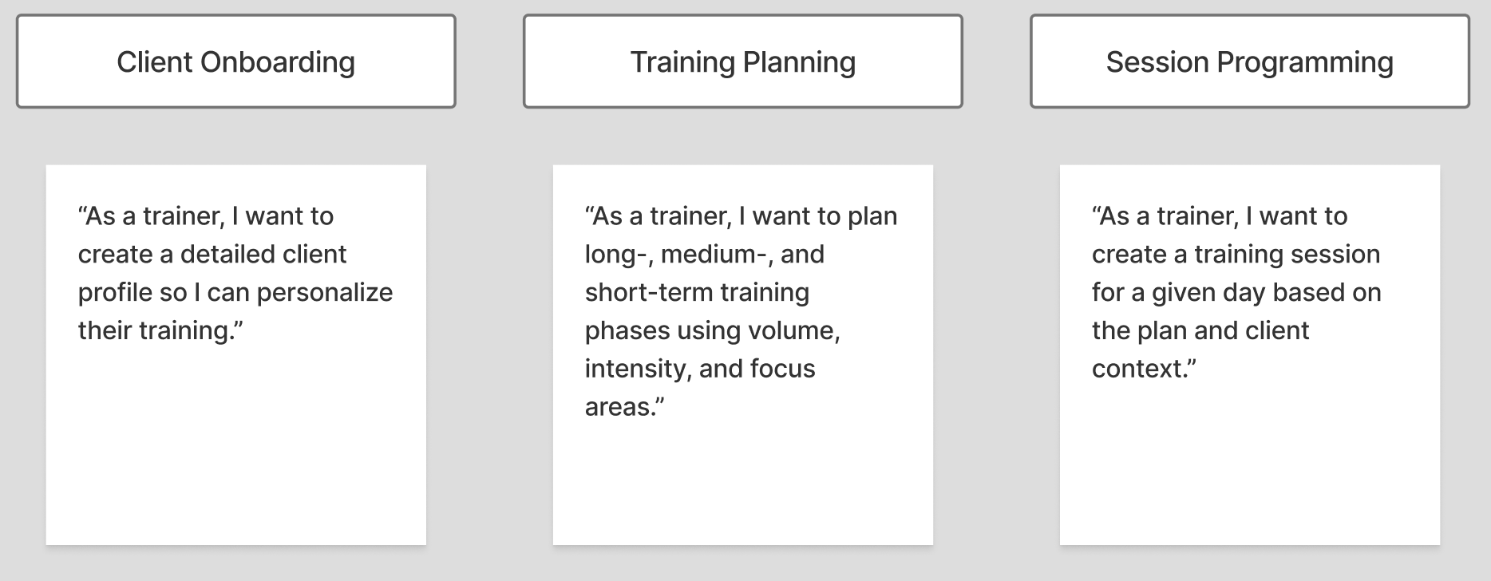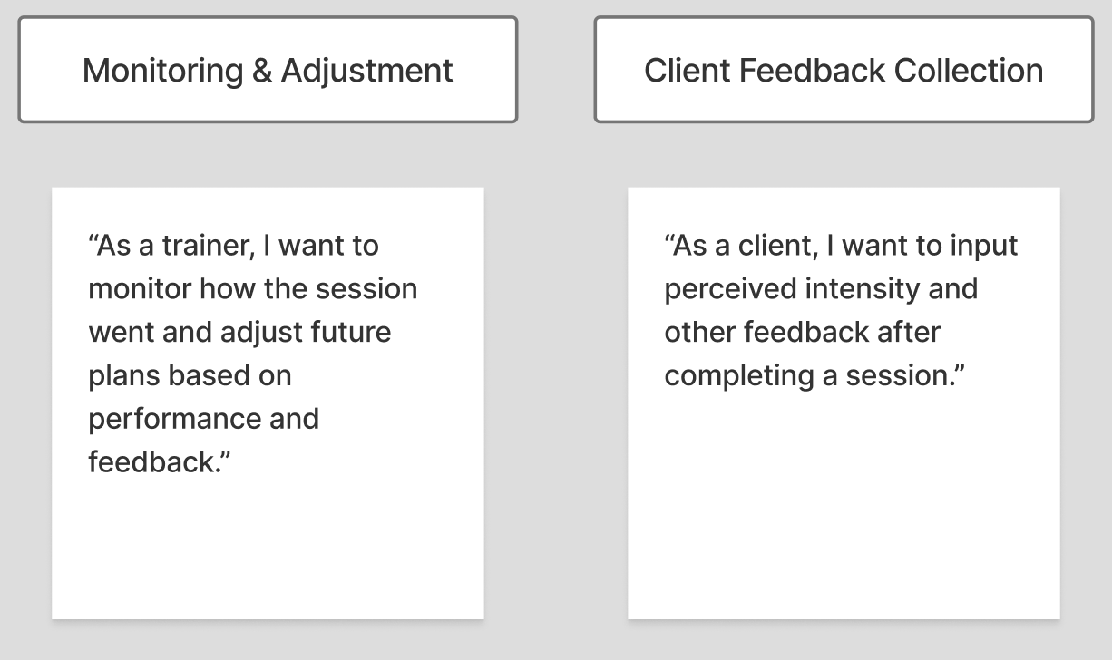

**User Action Technical Mapping**

| **Action** | **Input** | **Output** | **Related Screens** | **Possible Errors** |
| --- | --- | --- | --- | --- |
| **Create Client Profile** | Name, DOB, goals, experience, training frequency, session duration, anthropometric data | Client profile created with auto-generated recommendations | Client list, Client profile | Missing required fields, invalid data format, save failure |
| **Edit Client Profile** | Updated client information | Client profile updated | Client profile | Empty fields, update failure |
| **Create Training Plan** | Client (or group), volume, intensity, physical qualities | Training plan saved and assigned | Training plan list, Client profile | Empty values, logical inconsistency, save error |
| **Edit Training Plan** | Updated plan variables (monthly/weekly) | Plan updated successfully | Training plan editor, Client profile | Unaligned variables, save failure |
| **Create Training Session** | Exercises, sets, reps, rest, effort type | Session created for selected day | Calendar view, Session view, Client interface | Missing details, save error |
| **Submit Session Feedback** | RPE, weight used, fatigue questionnaire | Feedback saved, data visualized for trainer | Client dashboard, Monitoring dashboard | Skipped fields, submission failure |
| **Monitor Session Performance** | Client feedback and planned vs actual data | Deviation analysis with alerts | Monitoring screen, Trainer dashboard | Data sync issues, false alerts |
| **Delete Training Plan** | Plan ID | Plan removed from client profile and database | Training plan list | Assigned plan, delete blocked, database error |

Dashboard

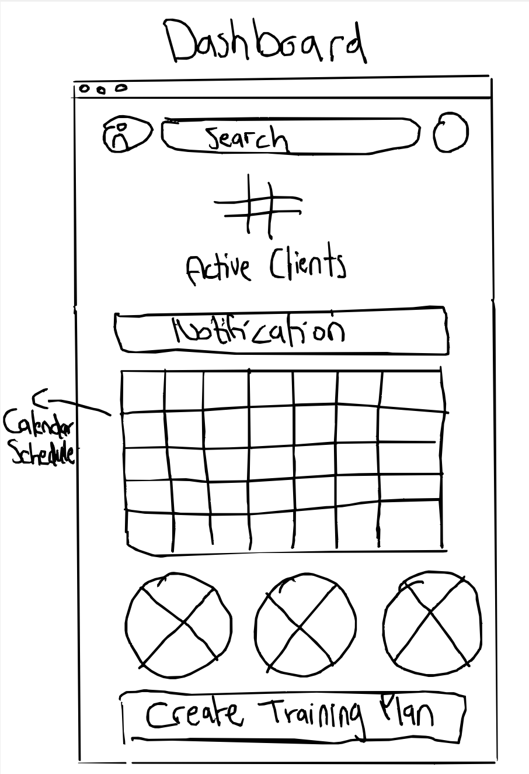

Client Onboarding

Start: Trainer clicks “Add New Client”

Goal: A fully set up client profile with enough data to generate training recommendations

End: Clicks “Create Client Profile” → sees confirmation → redirected to client dashboard with auto-generated training suggestions

**Steps:**

1. Add New Client
   * Button from home/dashboard or client list
2. Enter Basic Info
   * Name, surname, DOB → Auto-calculate age
   * Notes (optional)
3. Enter Anthropometric Data
   * Height, weight → Auto-calculate BMI
   * Skinfolds, diameters (optional)
   * Muscle mass %, fat %
4. Define Training Goal
   * Weight loss / Muscle gain / Performance
5. Define Experience & Availability
   * Experience level (low/med/high)
   * Training frequency (1–2 / 3–5 / 6–7 per week)
   * Session duration (<1h / 1h–1.5h / >1.5h)
6. Review & Confirm
   * Summary screen
   * Button: “Create Client Profile” → Triggers generation of training variable recommendations
7. Profile Creation
   * Redirect to client dashboard with default suggestions (volume, intensity, etc.)

**Flowchart:**

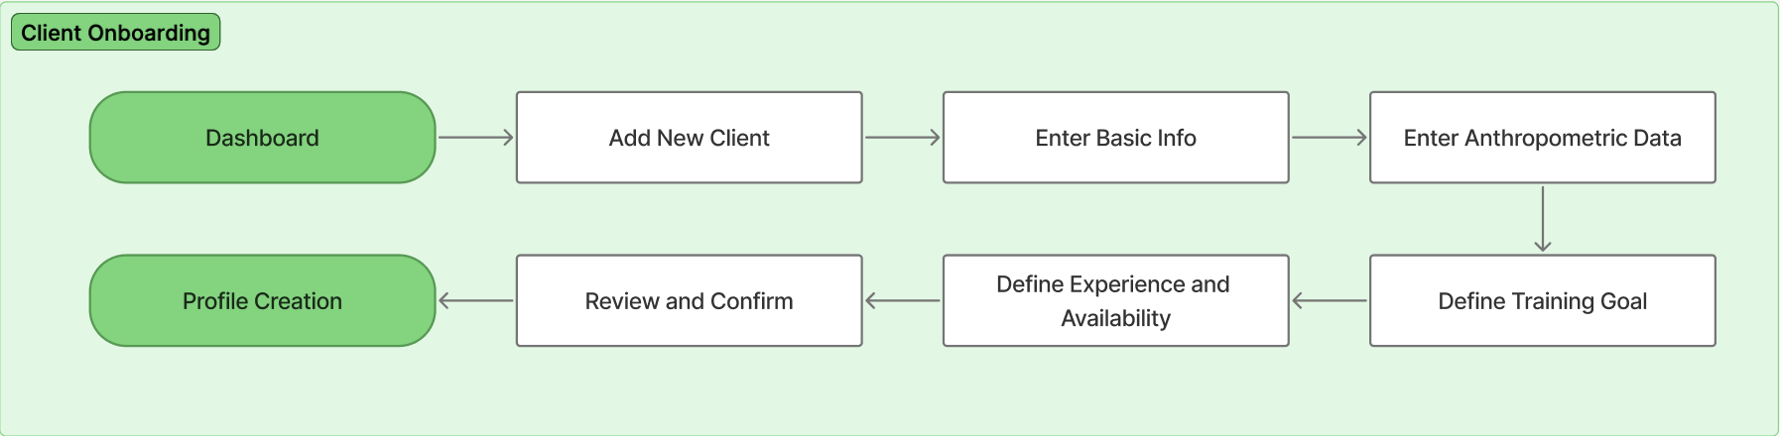

**Wireframes:**

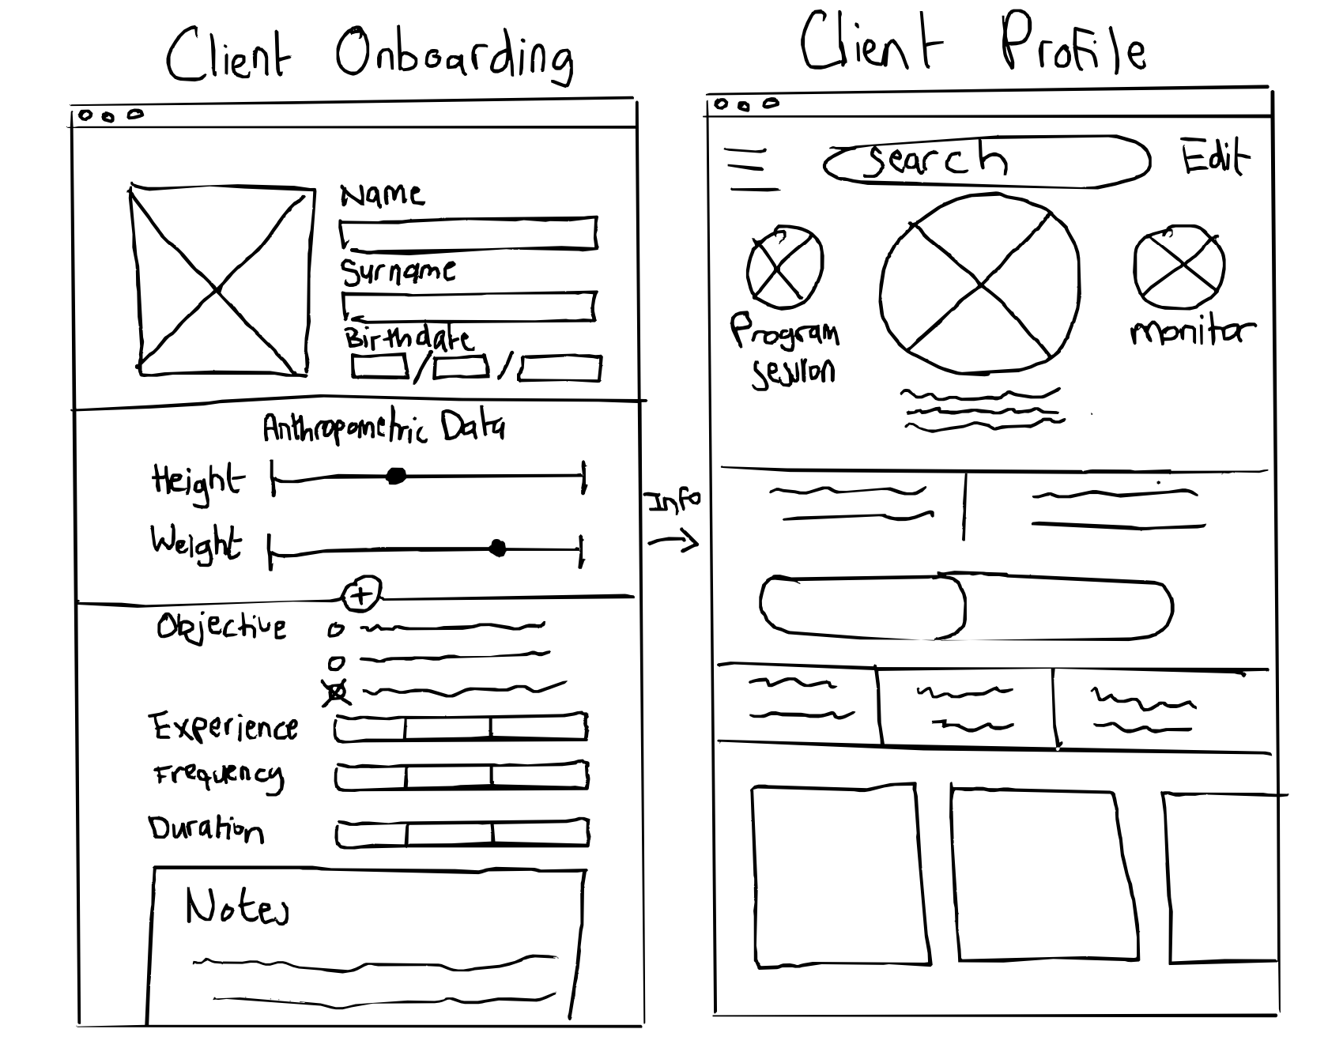

Training Planning

Start: Trainer clicks “Create Training Plan”

Goal: A structured plan assigning training volume, intensity, and physical qualities across timeframes

End: Clicks “Save Plan” → sees confirmation → training plan becomes active and accessible from client profile

**Steps:**

1. Access Training Planning
   * From the client profile or dashboard
   * Option to “Create New Plan” or “Edit Existing Plan”
2. Choose Plan Type
   * Option 1: Create a fully personalized plan for a single client
   * Option 2: Create a shared program for multiple clients (e.g., group training, CrossFit) - Content is shared across clients and individual progress, fatigue, and results are tracked separately
3. Annual Planning
   * Set volume and intensity per month (scale 1–10)
   * Select focus physical qualities (e.g., strength, endurance, etc.)
   * Assign each quality a % of importance linked to total training volume
4. Monthly Planning
   * Break each month into weeks
   * Adjust weekly volume, intensity, and focus to align with monthly goals
   * System flags major deviations
5. Weekly Planning
   * Assign daily training variables (volume, intensity, qualities)
   * Track adherence to weekly plan
   * App notifies trainer of any discrepancies in real time
6. Review & Confirm
   * Summary of planned variables across all levels
   * Trainer can edit or finalize plan
7. Plan Activation
   * Save and return to client profile
   * Training plan now drives session programming and future recommendations

**Flowchart**

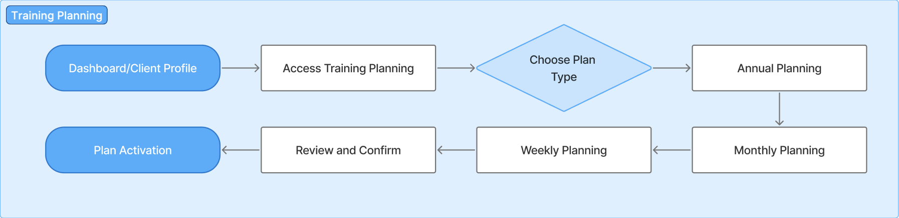

**Wireframes:**

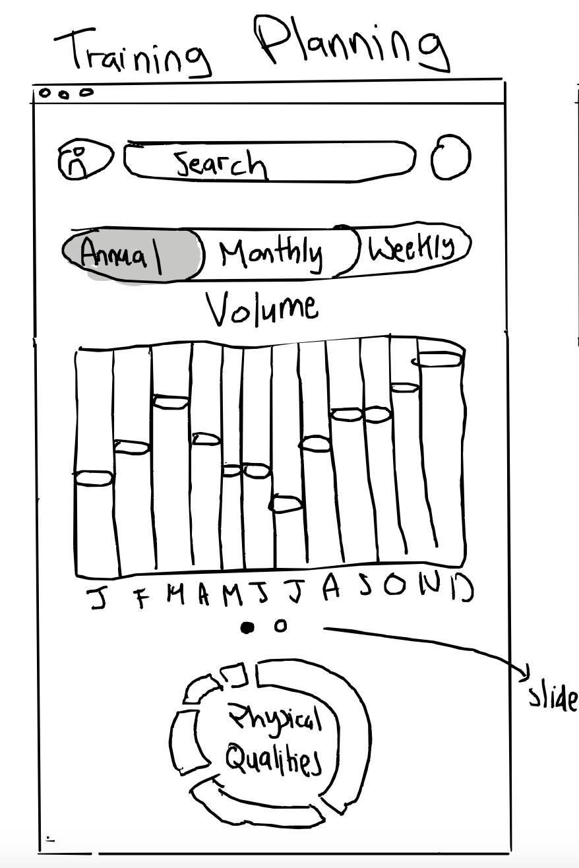

Session Programming

Start: Trainer selects a planned training day for a client

Goal: Build a complete training session based on plan, client context, and desired structure

End: Clicks “Save Session” → session appears in client interface

**Steps:**

1. Select Day to Program
   * From training plan calendar or client dashboard
   * Click on specific date to open session editor
2. Review Planned Variables
   * App displays pre-set volume, intensity, and focus for the day
   * Trainer reviews to guide session creation
3. Choose Routine Type
   * App recommends session type based on:
     1. Client experience level
     2. Training frequency
     3. Session duration
   * Trainer can accept or modify suggestion
4. Build Session Blocks
   * Trainer adds training blocks based on planned focus (e.g., strength, hypertrophy, etc.)
   * For each block, trainer defines:
     1. Exercise
     2. Sets
     3. Set type (e.g., single, super set, drop set)
     4. Repetitions
     5. Effort characterization (RPE, RIR, or % velocity loss)
     6. Rest time (if applicable)
5. Preview Client Input Fields
   * Client will later input:
     1. Weight used (if external load)
     2. RPE after each set
6. Review & Save Session
   * Trainer reviews session structure
   * App flags any mismatch with original plan
   * Click “Save Session” to publish
7. Session Saved
   * Client sees session in their interface
   * Ready for execution and monitoring

**Flowchart:**

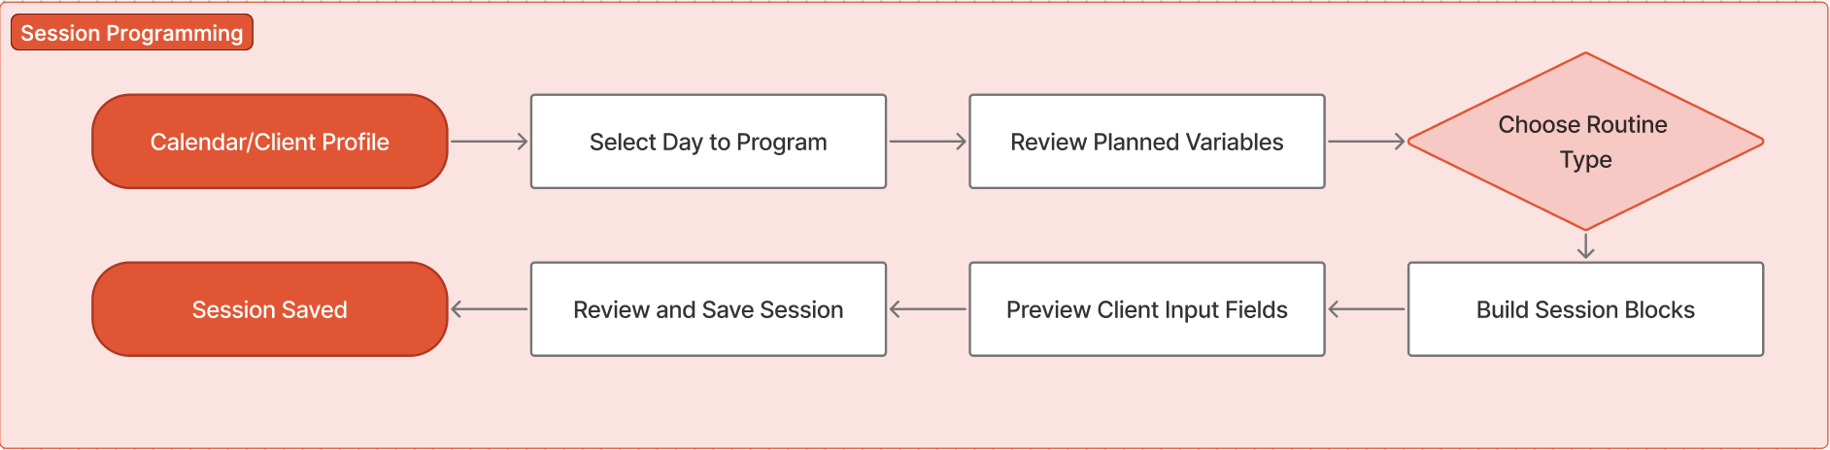

**Wireframes:**

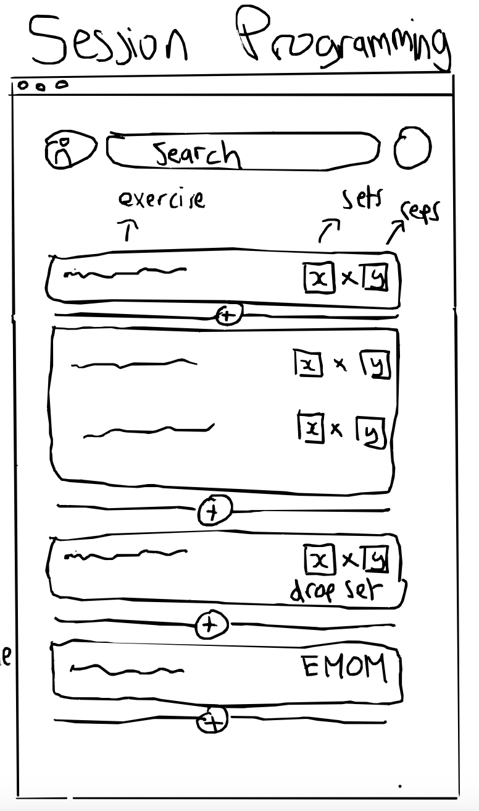

Monitoring and Adjustment

Start: Client completes a training session

Goal: Track alignment between planned, programmed, and perceived intensity — and make informed adjustments if needed

End: Trainer views analysis → optionally adjusts future plan → summary stored in client history

**Steps:**

1. Session Completion by Client
   * Client logs workout data after completing session
   * Inputs include:
     1. RPE (Rate of Perceived Exertion) for each set or session
     2. Weight used (if applicable)
2. Compare Planned vs. Programmed vs. Perceived
   * Planned intensity and volume (from training plan)
   * Programmed session structure
   * Client’s actual reported effort (perceived intensity)
3. Display Deviations
   * Trainer is shown the differences between planned and executed session
   * Shown the differences between programmed intensity and perceived intensity
4. Alert Generation
   * If a significant mismatch is detected app notifies the trainer and suggests checking in with the client
5. Pre-Session Adjustment (Optional)
   * Before next session, client completes a quick fatigue & recovery check
   * App recommends adjusting volume/intensity accordingly
   * Trainer can accept or override
6. Trainer Review & Adjustment
   * Trainer reviews summary dashboard
   * Makes manual adjustments to future training if needed
   * Notes are stored in client history
7. Continue with Program
   * Feedback loop informs upcoming session planning and AI recommendations

**Flowchart:**

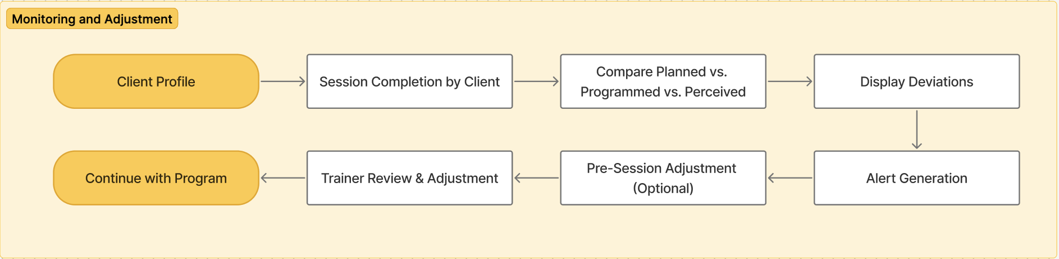

**Wireframes:**

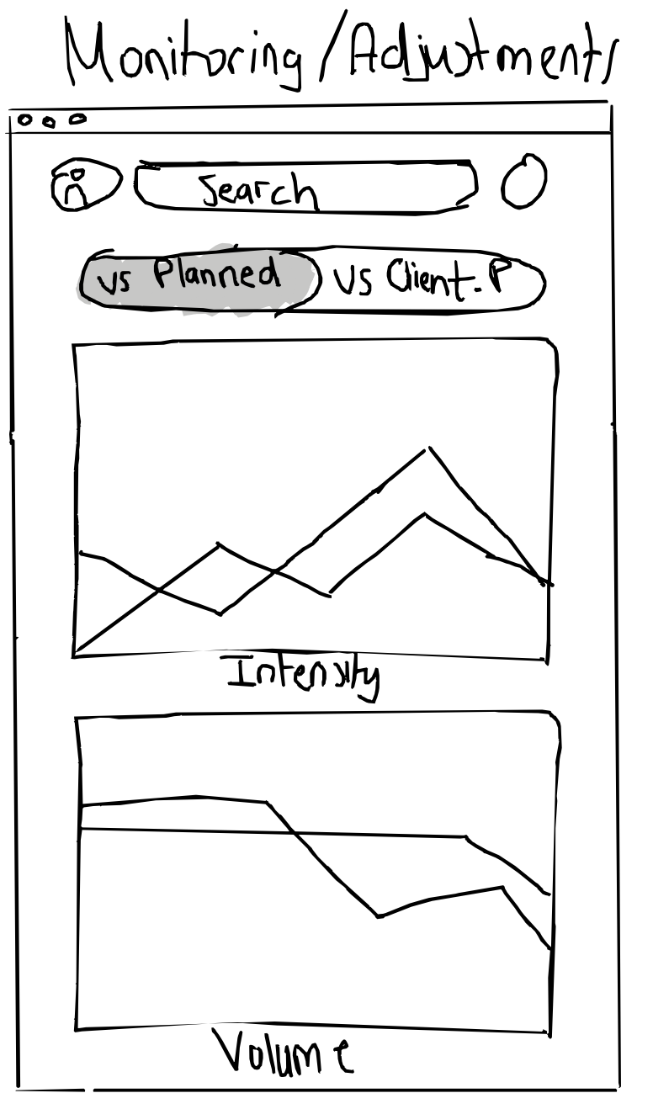

Client Feedback Collection

Start: Client opens the app after completing a session

Goal: Submit feedback to help track performance, fatigue, and inform future adjustments

End: Data stored → informs trainer and adjusts recommendations where relevant

Steps:

1. Session Feedback Prompt
   * After completing a workout, the app prompts the client to provide input
   * Accessible via notification or post-session screen
2. Input Performance Data
   * Client fills in:
     1. Weight used (if applicable)
     2. RPE (Rate of Perceived Exertion) for each set or overall session
     3. Optional: Add comments (e.g., discomfort, energy levels)
3. Fatigue & Recovery Check (Pre-Next Session)
   * Before their next scheduled session, client is prompted to complete a brief check-in
4. Automatic Analysis
   * The system uses feedback to: detect overtraining risks, recommend session intensity/volume changes and highlight unusual patterns for trainer review
5. Trainer Alert (if applicable)
   * If data shows significant fatigue or mismatch, app alerts trainer
   * Trainer can take action or override recommendations
6. Feedback Stored in Client Profile
   * All responses are stored and tracked over time
   * Visualizations help monitor trends (e.g., chronic fatigue, inconsistent effort)

Flowchart:

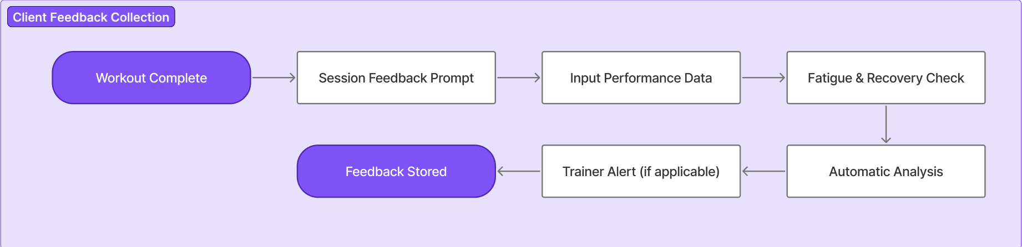

Full Application Architecture Diagram

